Lab Report No 1

Getting Started with Python
Artificial Intelligence



Submitted By:
[Huzaifa Shahbaz]
[21-CE-009]
[Aqsa Shah]
[21-CE-039]

Submitted to:
Engr. Hareem Khan
Dated:
4thMar,2025

Department of Computer Engineering,
HITEC University, Taxila
Lab Task No 8:

Solution:
Brief description (3-5 lines)
Write a Python program to check if the given number is a Disarium Number. A number is said to be the Disarium number when the sum of its digit raised to the power of their respective positions becomes equal to the number itself.
For example, 175 is a Disarium number as follows:
1¹+ 7²+ 5³= 1+ 49 + 125 = 175
The code
def is_disarium_number(number):
# Convert the number to a string to easily iterate through its digits
num_str = str(number)
# Calculate the sum of digits raised to their respective positions
disarium_sum = sum(int(digit) ** (index + 1) for index, digit in enumerate(num_str))
# Check if the sum equals the original number
return disarium_sum == number
# Test the function with some example numbers
def test_disarium_numbers():
# Test cases
test_numbers = [175, 89, 135, 518, 100, 200]
for num in test_numbers:
result = is_disarium_number(num)
print(f"{num} is {'a' if result else 'not a'} Disarium number")
# Run the test function
test_disarium_numbers()
The results (Screenshot)
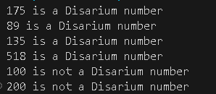
Lab Task No 9:

Solution:
Brief description (3-5 lines)
Write a Python program to determine whether the given number is a Harshad Number. If a number is divisible by the sum of its digits, then it will be known as a Harshad Number.
For example:
The number 156 is divisible by the sum (12) of its digits (1, 5, 6)
Some Harshad numbers are 54, 120, etc.
The code
def is_harshad_number(number):
# Convert the number to a string to easily iterate through its digits
num_str = str(number)
# Calculate the sum of digits
digit_sum = sum(int(digit) for digit in num_str)
# Check if the number is divisible by the sum of its digits
return number % digit_sum == 0
def main():
# Test the function with some examples
test_numbers = [54, 120, 156, 18, 10, 22, 100, 63]
print("Harshad Number Checker")
print("-" * 25)

for num in test_numbers:
result = is_harshad_number(num)
print(f"{num} is{' ' if result else ' not '}a Harshad Number")
if result:
print(f" Digit Sum: {sum(int(digit) for digit in str(num))}")
print()
# Allow the script to be run directly or imported as a module
if __name__ == "__main__":
main()

The results (Screenshot)
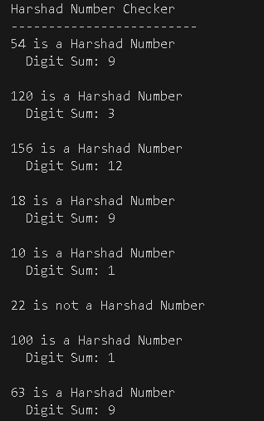
Conclusion
In conclusion, Harshad and disarium numbers are rare mathematical breeds, with Harshad numbers being divisible by their digit sum, and disarium numbers showing symmetry when raised to successive powers. These numbers demonstrate how numbers can be related through digits and mathematical relationships, allowing mathematicians and number theory enthusiasts to understand elegant patterns hidden in numerical sequences. These classifications have given glory to mathematicians and number theory enthusiasts.

